**Diary Re-assignment Module**

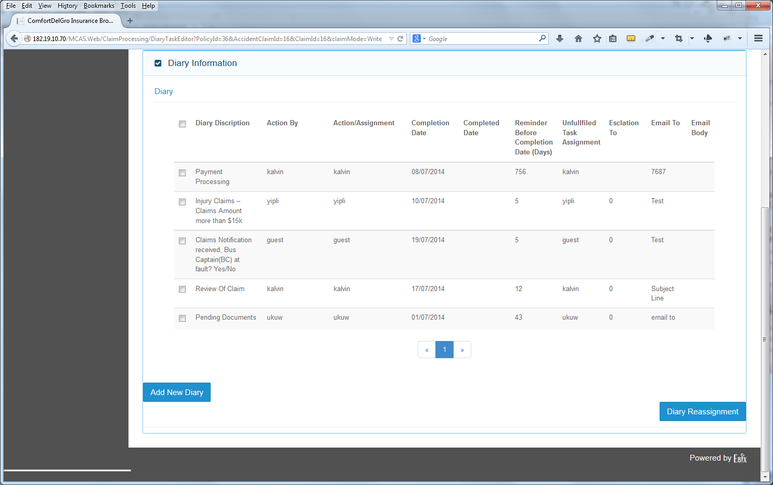

1. Need to have clear indications on this screen for those Entries that have been re-assigned:

1. To Who
2. Status – Permanent / Temporary
3. If Temporary – what is the Time Frame – Re-assigned Date From & Re-assigned Date To

2. Users that have received Re-assigned Tasks will be able to see these Cases in their Diary and they have the similar function to re-assign back to the original user or to other users (there are situations whereby this user cannot take on the re-assigned tasks).

Note: if **User A** has re-assigned a task on a Temporary basis, e.g. from 18 July to 25 July 2014 to **User B** and **User B** has to re-assign to **User C**, the System should take note of this 25 July 2014 date to prevent overlapping of the date.

**Point(s) To Discuss:** Should the tasks pertaining to a particular claim be re-assigned as a whole to another user or part by part when the original user cannot handle it? If it is part by part – will it be a long list of tasks to be displayed when the re-assigned User views his Assigned Task Listing Module.

Yip – so as not to complicate the process, we provide only 1 only – assign to new party and re-assign back to original party, regardless of temporary or permanent. Multi-party re-assignment will make the process too complex. The original assigning party will lose track of the intended tracking and performance purpose if multiple re-assignment happens.

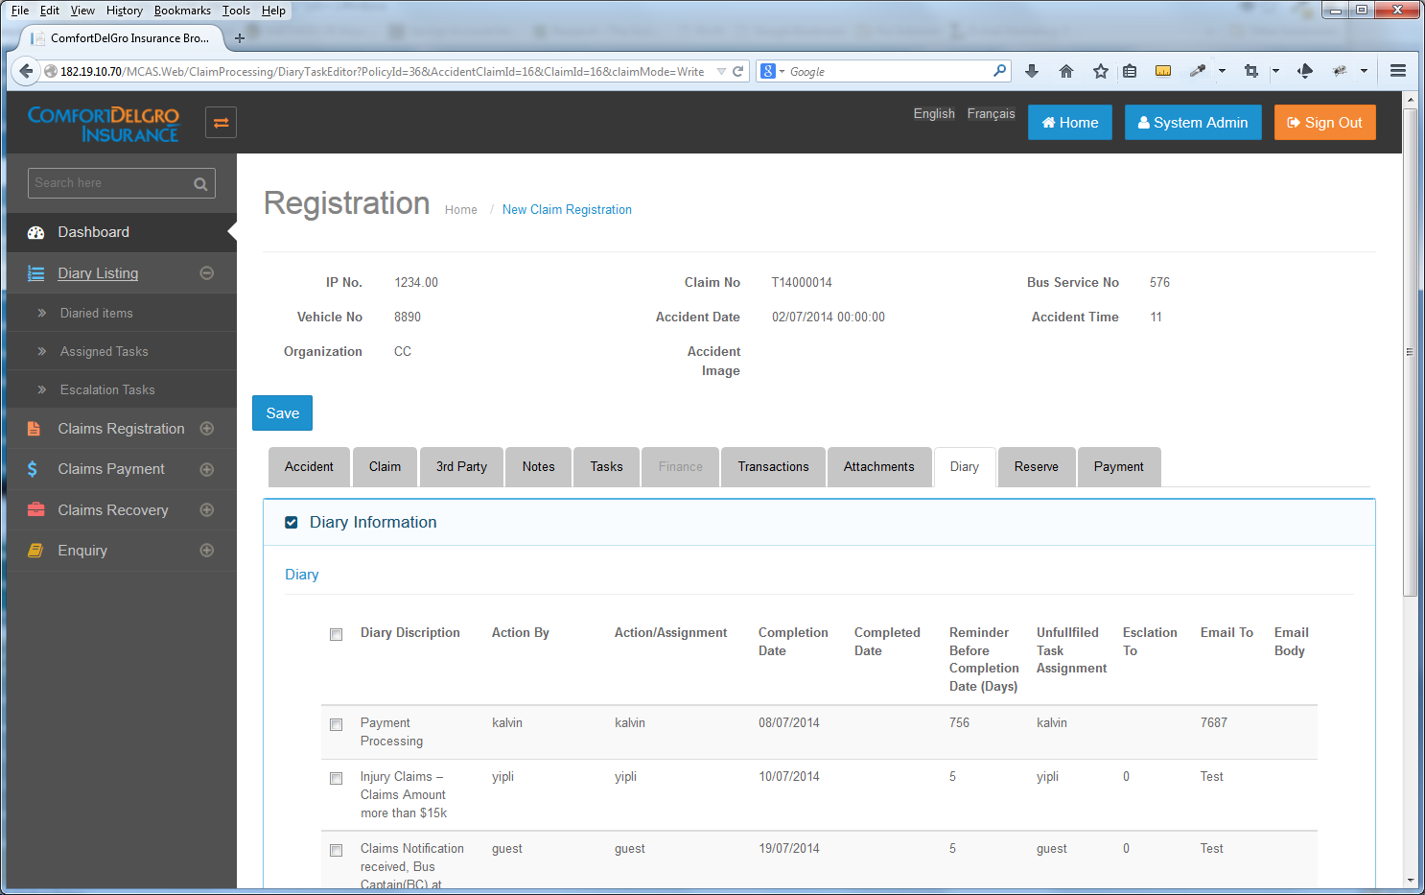

**3. Under Diary Listing > Assigned Tasks Listing Module.** This is the section for Users to see all their Assigned Tasks and Re-assigned Tasks. There should be a clear indication of Re-assigned Tasks for the Users to see in a glance. This Listing Module should allow Users to perform Re-assignment back or to other Users as well.

Yip – delete the function for receiving party to re-assign to another party. For the three party assignment to effect, the re-assigned party must assign back to original party.

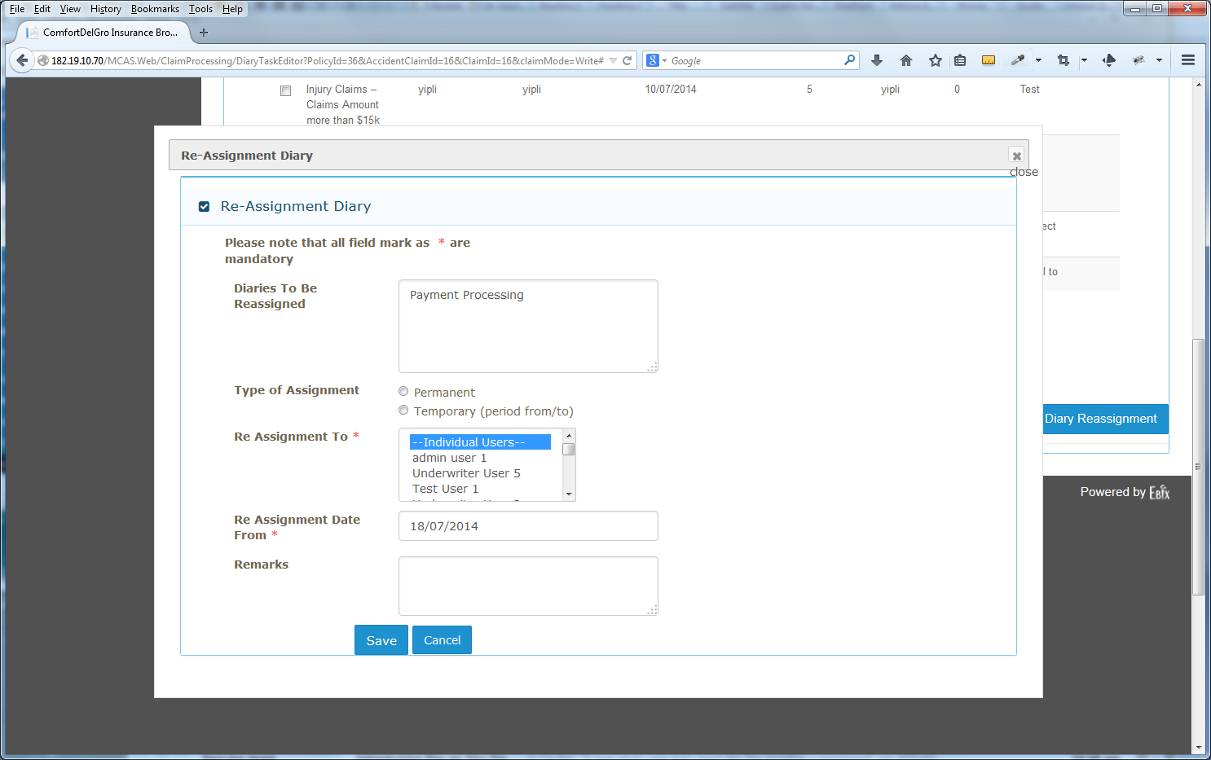

4. There is a missing field – “Re Assignment Date To” when the Temporary Field is chosen.

5. The Re Assignment To Field should / should not allow multiple users to be re-assigned.

6. When the User clicks on Save – the System will trigger an email and send to the Assigned User(s) that they have received re-assigned task(s).

Sample Email Subject: “Claim #” – You Have Re-assigned Task(s).

Sample Email Body: You have been re-assigned the following tasks for “Claim #”:

1. “Diaries to be Reassigned #1”
2. “Diaries to be Reassigned #2”

Please kindly check your Diary of Assigned Tasks.